**GRADUATION PROJECT REPORT DRAFT**

|  | Student Name Surname | Student Name Surname | Consultant Name Surname |  |
| --- | --- | --- | --- | --- |
|  | *ogrenci1@ktu.edu.tr* | *ogrenci2@ ktu.edu.tr* | *danisman@ktu.edu.tr* |  |

Department of Electronics and Communication Engineering

Of Technology Faculty, Karadeniz Technical University, Trabzon

**Summary**

Karadeniz Technical University, Faculty of Technology, Department of Electronics and Communication Engineering, Of Technology Faculty, 7th and 8th semesters of Design Project and Graduation Study courses, the Graduation Projects carried out by the students in the 7th and 8th semesters will also be prepared in a paper format and will be published collectively as a *Graduation Project Proceedings Book* in PDF format. The versions of the Graduation Projects that will be exhibited and presented in the last 3 days of the final exams at the end of the spring semester will be included in this booklet. These papers will also be published as special issues in the Sector journals, if agreed upon. This document is an outline of how the papers will be prepared. The maximum length of a paper is 4 pages.

# Introduction

This sample is also available on the department web page. Please prepare the text of the paper as MS-Word file in accordance with the format in this example and send it as a PDF file. Information on submission and evaluation of papers can be found at <http://eee.ktu.edu.tr>.

# Page Layout and Format

The page layout must be prepared in accordance with the following rules. It is strongly recommended that you use a ready-made outline (Word, this outline) or follow a sample file to check the details in order to fulfill these requirements.

## Warning Regarding Author Names!

Author names should be written in accordance with the example above, with the student names first and then the advisor's name. If the number of students is more than 2, they are written in order. If necessary, continue from the 2nd line. The order of student names is determined by the advisor. The valid e-mail address of each author is written on the line following the name of the university. The advisor is also the contact person for this paper. All communication outside the department is made with the advisor after the head of the department. The advisor informs the students whose names are on the paper about the developments.

## Basic Layout Features

* Papers should be prepared in A4 format.
* The text should consist of two columns, except for the title and the use of page-wide figures.
* Left and right margins 2 cm,
* Space between columns 0.6 cm,
* All margins are 2.0 cm (top margin of the first page is 3 cm to the title of the paper),
* Page title and footer should be left blank.
* Paragraphs should not be indented and one line space should be left between two consecutive paragraphs.
* The writing format of this file can be taken as an example.

### Headlines

Section titles should be bold and left justified, only the initial letter of the first word in the title should be capitalized, and the rest of the title should be written in lowercase letters in 12-point font. Subheadings should be written in the same format as the main headings in 11 pt. Other headings under sub-headings should be written in the same format as the sub-headings, only in italicized letters, without being bolded.

## Font Type

*Times* or *Times New Roman* should be used for the main text. The recommended character size and also the smallest size that can be used is 10 points. Other typefaces may be used in special cases. All typefaces used when the latest pdf file was created must be included.

## Shapes

All figures should be centered by column (or page if the figure covers both columns). The captions of the figures should be written below each figure and should be in the order shown in Figures 1, 2 and 3. The font used in the figures and the font used in the text should be compatible and easy to read.

If the shapes contain dark or colored areas, they should be checked for proper printability on high-quality, colorless laser printers.

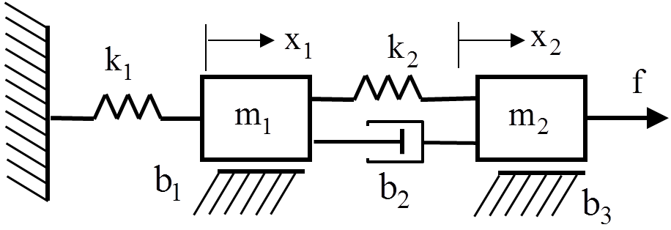

*Figure 1*: An example of a shape.

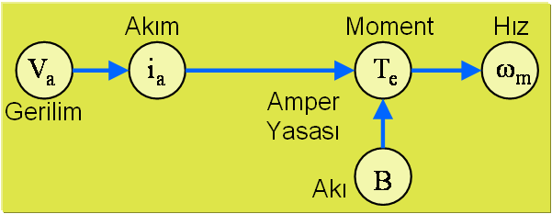

*Figure 2*: Another example of a shape.

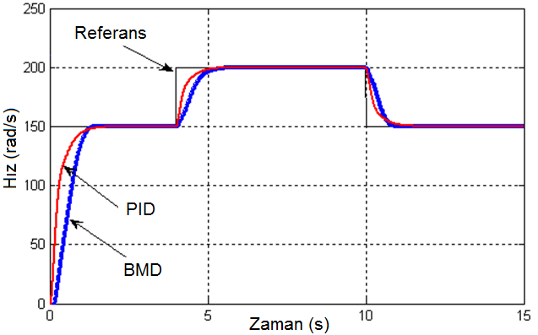

*Figure 3*: Another example of a shape.

## Schedules

An example is given in Table 1. Different charts can be used according to the type and purpose of use. The title of the chart should be placed at the top of the chart according to the example.

*Chart 1*: An example of a chart

| Database | Education | | Test |
| --- | --- | --- | --- |
| BUPA | 100 | 94,78 | |
| E.coli | 94,60 | 90,35 | |
| Glass | 98,67 | 95,31 | |

## Equations

Each equation should be written on separate lines and numbered. Some examples are given below. References to equations should be made with equation number (1) in parentheses.

(1)



(2)



(3)



## Hyperlinks

*Hyperlinks* can be used in the paper. However, make sure that the *Hyperlinks* you use will not cause problems after conversion to PDF format.

## Adding Software

The paper should include a flowchart instead of software code.

## Page Numbers

Page numbers should be centered at the bottom of the page.

## Sources

The format of references is the standard IEEE reference format. References should be numbered in the order in which they are used. For example [1], [2] and [3]. References given at the end of the same line following each other in sequence can be combined by specifying the starting and ending reference numbers. For example, [1-5] can be given instead of [1], [2], [3], [4], [5]. The list of references at the end should be written in 9-point font.

# Submission of Papers

Papers must be submitted in pdf file format by filling out the relevant form on the Graduation Project Paper Submission interface under the Graduation Project sub-heading on the Department web page. The department web page can be accessed at http://eee.ktu.edu.tr. The form indicating that the advisor has given permission to print the paper must also be approved and scanned and combined with the paper file in a .rar or .zip file and sent as a single file. The name of the file should be the Project Number given in the Graduation Projects Presentation Program. For example, a name such as *bit056.zip* should be given to represent the graduation project numbered 56.

# Conclusion

The papers of the Graduation Projects that have passed the Graduation Project Preliminary Evaluation must be submitted by the evening of the first day of the Graduation Projects exhibition held at the end of each spring semester. Papers that are not submitted on time or do not have pdf file format will not be considered.

In order for the papers to be included *in the Proceedings Book, they* must be prepared in accordance with the spelling rules and the graduation study of the paper must be found successful by the exam jury. In addition, the *Graduation Project* advisor's approval form for the publication of the paper must be scanned and sent as described above. This approval form can be accessed from the Graduation Project sub-heading on the Department web page.

The results and evaluations of your work can be given under this heading. Each result form used must be cited and explained in the text. The *Graduation Project Writing Guide* can be consulted regarding the writing of the results.

# Acknowledgements

If there were people who provided financial support during your work, they can be thanked in this section. Family and friends should not be thanked here.

# Sources

1. A1. Surname1 and A2. Surname2, "Article title", *Journal of publication*, Volume No, Page, Year.

1. A. Surname, (Editor, if any) *Book title,* Publisher, Place of publication, Year of publication.

1. A1. Surname1, A2. Surname2 and A3. Surname3, "Title of the paper", *Symposium or conference booklet in which it was published*, Year, Page.

The first letters of the first and second names of the authors should be abbreviated and the surnames should be written clearly. When writing the surname, only the first letter should be capitalized. IEEE source writing rules are applied in writing references. Detailed explanations on how to write the references are given *in the Graduation Project Writing Guide*, which is the most valid source on this subject. This manual can be accessed from the *Graduation Project* sub-heading of the department web page.

# Attachments

Appendices, if any, are given in this section. The spelling rules of the appendices are the same as the other parts of the paper. The paper should be maximum 4 pages including appendices.