



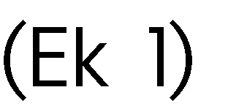



|  |  |
| --- | --- |
|  |  |
|  |  |
|  |  |
|  |  |
|  |  |
|  |  |
|  |  |
|  |  |
|  |  |
|  |  |
| 1)  2)  3)  4) | |



|  |  |  |  |
| --- | --- | --- | --- |
|  |  |  |  |
|  |  |  |  |
|  |  |  |  |